**Project Deliverable #02**

Actors, Use Cases, UCD, UC Scenarios

**Online Test Management System**

**Group #01**

Hamza Zulfiqar (201370105)

Anzah Nadeem (201370005)

Musa Nabeel (201370012)

Akasha Farrukh Iqbal (201370031)



## **Actors**

* Student
* Admin

## **Use Cases**

**Student:**

* Student registration
* Student login
* Attempt Questions
* Quit Session

**Admin:**

* Provide login
* Load questions
* Drop questions
* Add subject
* Drop subject
* Check questions
* Publish result
* Save data

## Use Case Diagram

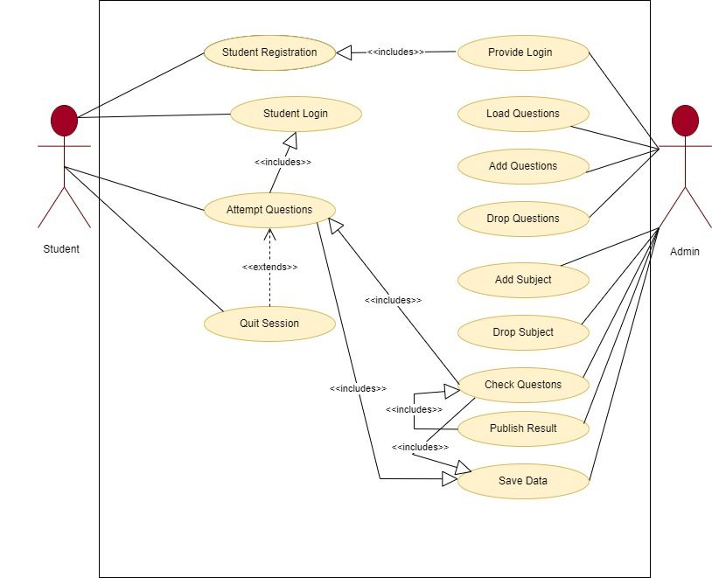

## **Use Case Scenarios**

| **<UC-01: Student Registration>** | | | | | |
| --- | --- | --- | --- | --- | --- |
| **Actors:**  Student | | | | | |
| **Feature:** | | |  | | |
| **Use case Id:** | | | *01* | | |
| **Pre-condition:** | | |  | | |
| **Scenarios** | | | | | |
| **Step#** | **Action** | | | **Software Reaction** | |
| **1** | *A student wants to appear in the online exam.* | | |  | |
| **2** | *The student registers himself on the application by providing his full name, username, password, email address, and country.* | | | *Students’ credentials are inserted into the system.* | |
| **3** |  | | | *The system generates a login and password for the student, and notifies admin.* | |
| **4** | *Student registered.* | | |  | |
| **Alternate Scenarios:** *Write additional, optional, branching, or iterative steps. Refer to specific action numbers to ensure understandability.* | | | | | |
| **Step#** | | **Action** | | | **Software Reaction** |
| **1a:** | |  | | |  |
| **Post Conditions** The student is registered and his credentials are added to the DB. | | | | | |

| **<UC-02: Admin Provides Login>** | | | | | |
| --- | --- | --- | --- | --- | --- |
| **Actors:**  Admin | | | | | |
| **Feature:** | | |  | | |
| **Use case Id:** | | | *02* | | |
| **Pre-condition:** | | | *Admin is logged in to his account. Student has formerly registered and has provided his credentials.* | | |
| **Scenarios** | | | | | |
| **Step#** | **Action** | | | **Software Reaction** | |
| **1** | *Admin is notified that a new student registered himself.* | | |  | |
| **2** | *Admin checks credentials.* | | | *System provides the generated login and password to the admin.* | |
| **3** | *Admin provides login and password to the student.* | | |  | |
| **Alternate Scenarios:** *Write additional, optional, branching, or iterative steps. Refer to specific action numbers to ensure understandability.* | | | | | |
| **Step#** | | **Action** | | | **Software Reaction** |
| **1a:** | |  | | |  |
| **2a:** | |  | | |  |
| **Post Conditions** The student is provided with his login details. | | | | | |
| **Step#** | **Description** | | | | |
| **1** |  | | | | |

| **<UC-03: Question Adding By Admin>** | | | | | |
| --- | --- | --- | --- | --- | --- |
| **Actors:**  Admin | | | | | |
| **Feature:** | | |  | | |
| **Use case Id:** | | | *03* | | |
| **Pre-condition:** | | | *Admin is logged in to his account.* | | |
| **Scenarios** | | | | | |
| **Step#** | **Action** | | | **Software Reaction** | |
| **1** | *The admin wants to add a question.* | | |  | |
| **2** | *Admin selects the “add question” option from the admin interface.* | | | *The system opens a webpage, requesting the subject, new objective question to be added, and its 4 options.* | |
| **3** | *Admin provides the objective question, its 4 options, and the subject it is to be added to.* | | | *The system adds the objective question to the given subject portion.* | |
| **Alternate Scenarios:** *Write additional, optional, branching, or iterative steps. Refer to specific action numbers to ensure understandability.* | | | | | |
| **Step#** | | **Action** | | | **Software Reaction** |
| **1a:** | |  | | |  |
| **Post Conditions** The relevant question is added to the mentioned subject. | | | | | |
| **Step#** | **Description** | | | | |
| **1** |  | | | | |

| **<UC-04: Question Deletion By Admin>** | | | | | |
| --- | --- | --- | --- | --- | --- |
| **Actors:**  Admin | | | | | |
| **Feature:** | | |  | | |
| **Use case Id:** | | | *04* | | |
| **Pre-condition:** | | | *Admin is logged in to his account. The entered question number is present in the exam.* | | |
| **Scenarios** | | | | | |
| **Step#** | **Action** | | | **Software Reaction** | |
| **1** | *The admin wants to delete a question.* | | |  | |
| **2** | *Admin selects the “delete question” option from the admin interface.* | | | *The system requests the question number to be deleted.* | |
| **3** | *Admin provides the question number.* | | | *The system deletes the question from the exam.* | |
| **Alternate Scenarios:** *Write additional, optional, branching, or iterative steps. Refer to specific action numbers to ensure understandability.* | | | | | |
| **Step#** | | **Action** | | | **Software Reaction** |
| **1a:** | |  | | |  |
| **Post Conditions** The relevant question is deleted from the exam. | | | | | |
| **Step#** | **Description** | | | | |
| **1** |  | | | | |

| **<UC-05: Subject Adding By Admin>** | | | | | |
| --- | --- | --- | --- | --- | --- |
| **Actors:**  Admin | | | | | |
| **Feature:** | | |  | | |
| **Use case Id:** | | | *05* | | |
| **Pre-condition:** | | | *Admin is logged in to his account.* | | |
| **Scenarios** | | | | | |
| **Step#** | **Action** | | | **Software Reaction** | |
| **1** | *The admin wants to add a subject.* | | |  | |
| **2** | *Admin selects the “add subject” option from the admin interface.* | | | *The system requests the admin to enter the subject name and code to be added.* | |
| **3** | *The admin provides the subject name and code.* | | | *The system adds the specified subject, with the code specified.* | |
| **Alternate Scenarios:** *Write additional, optional, branching, or iterative steps. Refer to specific action numbers to ensure understandability.* | | | | | |
| **Step#** | | **Action** | | | **Software Reaction** |
| **1a:** | |  | | |  |
| **Post Conditions** The relevant subject is added to the exam. (Questions will be added to this subject via the the “Question adding” scenario) | | | | | |
| **Step#** | **Description** | | | | |
| **1** |  | | | | |

| **<UC-06: Subject Deletion By Admin>** | | | | | |
| --- | --- | --- | --- | --- | --- |
| **Actors:**  Admin | | | | | |
| **Feature:** | | |  | | |
| **Use case Id:** | | | *06* | | |
| **Pre-condition:** | | | *Admin is logged in to his account. The specified subject code is present in the exam.* | | |
| **Scenarios** | | | | | |
| **Step#** | **Action** | | | **Software Reaction** | |
| **1** | *The admin wants to delete a subject.* | | |  | |
| **2** | *Admin selects the “delete subject” option from the admin interface.* | | | *The system requests the admin to enter the subject code.* | |
| **3** | *The admin provides the subject code.* | | | *The system asks for confirmation through a pop-up dialogue box.* | |
| **4** | *The admin confirms the deletion process.* | | | *The system deletes the subject with the specified code.* | |
| **Alternate Scenarios:** *Write additional, optional, branching, or iterative steps. Refer to specific action numbers to ensure understandability.* | | | | | |
| **Step#** | | **Action** | | | **Software Reaction** |
| **1a:** | |  | | |  |
| **Post Conditions** The relevant subject is deleted from the exam. | | | | | |
| **Step#** | **Description** | | | | |
| **1** |  | | | | |

| **<UC-07: Question Loading By Admin>** | | | | | |
| --- | --- | --- | --- | --- | --- |
| **Actors:**  Admin | | | | | |
| **Feature:** | | |  | | |
| **Use case Id:** | | | *07* | | |
| **Pre-condition:** | | | *Admin is logged in to his account.* | | |
| **Scenarios** | | | | | |
| **Step#** | **Action** | | | **Software Reaction** | |
| **1** | *The admin wants to load questions for students.* | | |  | |
| **2** | *Admin chooses the “load questions” option from the admin interface.* | | | *The system asks for confirmation to load questions at the current time via a pop-up dialogue box.* | |
| **3** | *Admin confirms the query.* | | | *The system loads the questions for students to attempt.* | |
| **Alternate Scenarios:** *Write additional, optional, branching, or iterative steps. Refer to specific action numbers to ensure understandability.* | | | | | |
| **Step#** | | **Action** | | | **Software Reaction** |
| **1a:** | |  | | |  |
| **Post Conditions** Questions are loaded for students to attempt. | | | | | |
| **Step#** | **Description** | | | | |
| **1** |  | | | | |

| **<UC-08: Student Login>** | | | | | |
| --- | --- | --- | --- | --- | --- |
| **Actors:**  Student | | | | | |
| **Feature:** | | |  | | |
| **Use case Id:** | | | *08* | | |
| **Pre-condition:** | | | *The student is a fully registered person.* | | |
| **Scenarios** | | | | | |
| **Step#** | **Action** | | | **Software Reaction** | |
| **1** | *The student wants to login.* | | |  | |
| **2** | *The student enters his login and password.* | | | *The system will verify the login and password.* | |
| **3** |  | | | *The system logs the student in and takes him to his personalized student interface.* | |
| **Alternate Scenarios:** *Write additional, optional, branching, or iterative steps. Refer to specific action numbers to ensure understandability.* | | | | | |
| **Step#** | | **Action** | | | **Software Reaction** |
| **1a:** | |  | | |  |
| **Post Conditions:** The student has logged into his/her account. | | | | | |
| **Step#** | **Description** | | | | |

| **<UC-09: Exam Attempting By Student>** | | | | | |
| --- | --- | --- | --- | --- | --- |
| **Actors:**  Student | | | | | |
| **Feature:** | | |  | | |
| **Use case Id:** | | | *09* | | |
| **Pre-condition:** | | | *The questions are loaded by the admin panel. The student is logged into his account.* | | |
| **Scenarios** | | | | | |
| **Step#** | **Action** | | | **Software Reaction** | |
| **1** | *The student wants to attempt the exam.* | | |  | |
| **2** | *The student selects the “Attempt exam” option on his logged-in student interface.* | | | *The system loads the objective questions for the student to attempt.* | |
| **3** | *The student attempts the exam question by choosing one of the 4 options provided.* | | | *The system stores the answer.* | |
| **4** | *The student completes the exam.* | | | *The system stores all answers in one place of the database, with the username of the password associated with the set of answers.* | |
| **Alternate Scenarios:** *Write additional, optional, branching, or iterative steps. Refer to specific action numbers to ensure understandability.* | | | | | |
| **Step#** | | **Action** | | | **Software Reaction** |
| **3a:** | | *The student repeats the process for each question of each section. (iterative)* | | | *The system stores each answer for each question.* |
| **Post Conditions** The student has attempted all questions and answers are stored in the system database. | | | | | |
| **Step#** | **Description** | | | | |

| **<UC-10: Exam Checking By Admin>** | | | | | |
| --- | --- | --- | --- | --- | --- |
| **Actors:**  Admin | | | | | |
| **Feature:** | | |  | | |
| **Use case Id:** | | | *10* | | |
| **Pre-condition:** | | | *The admin must be logged in. The student must have attempted the exam. The system must have stored all answers in the database.* | | |
| **Scenarios** | | | | | |
| **Step#** | **Action** | | | **Software Reaction** | |
| **1** | *The admin is notified that the student has completed the exam.* | | |  | |
| **2** | *The admin requests access to the stored answers.* | | | *The system retrieves data from the database and displays it on the admin interface.* | |
| **3** | *The admin identifies whether each question has been attempted correctly.* | | | *The system stores the result of each identification — using 1 for correct answers and 0 for incorrect answers.* | |
| **4** | *The admin will complete the checking of one particular exam.* | | | *The system will calculate the total number of correctly attempted questions.* | |
| **5** |  | | | *The system calculates the grade based on a preset percentage: 90+ (A+), 80+ (A), 70+ (B), 60+ (C), 50+ (D), 40+ (E), under 40 (F)* | |
| **6** |  | | | *The system will declare results, making it visible to the student.* | |
| **Alternate Scenarios:** *Write additional, optional, branching, or iterative steps. Refer to specific action numbers to ensure understandability.* | | | | | |
| **Step#** | | **Action** | | | **Software Reaction** |
| **3a:** | | *The admin repeats the process for each question of each section. (iterative)* | | | *The system stores each result for each question.* |
| **Post Conditions** The result is calculated and displayed on the student interface. | | | | | |
| **Step#** | **Description** | | | | |

| **<UC-11: Quit Session By Student>** | | | | | |
| --- | --- | --- | --- | --- | --- |
| **Actors:**  Student | | | | | |
| **Feature:** | | |  | | |
| **Use case Id:** | | | *11* | | |
| **Pre-condition:** | | | *The student must be logged in. The student should be attempting the exam.* | | |
| **Scenarios** | | | | | |
| **Step#** | **Action** | | | **Software Reaction** | |
| **1** | *The student wants to quit the session.* | | |  | |
| **2** | *The student selects the “Quit” option displayed on the bottom of the screen.* | | | *The system asks for a confirmation to quit via a pop-up dialogue box.* | |
| **3** | *The student confirms.* | | | *The system exits and logs out the student.* | |
| **Alternate Scenarios:** *Write additional, optional, branching, or iterative steps. Refer to specific action numbers to ensure understandability.* | | | | | |
| **Step#** | | **Action** | | | **Software Reaction** |
| **3a:** | |  | | |  |
| **Post Conditions** The student has quit the session. | | | | | |
| **Step#** | **Description** | | | | |

| **<UC-12: Data Saving By Admin>** | | | | | |
| --- | --- | --- | --- | --- | --- |
| **Actors:**  Admin | | | | | |
| **Feature:** | | |  | | |
| **Use case Id:** | | | *12* | | |
| **Pre-condition:** | | | *The admin must be logged in.* | | |
| **Scenarios** | | | | | |
| **Step#** | **Action** | | | **Software Reaction** | |
| **1** | *The admin wishes to save data.* | | |  | |
| **2** | *The admin requests the system to save using the “save” option.* | | | *The system saves the relevant data to the database.* | |
| **Alternate Scenarios:** *Write additional, optional, branching, or iterative steps. Refer to specific action numbers to ensure understandability.* | | | | | |
| **Step#** | | **Action** | | | **Software Reaction** |
| **3a:** | |  | | |  |
| **Post Conditions** The data is saved to the database. | | | | | |
| **Step#** | **Description** | | | | |